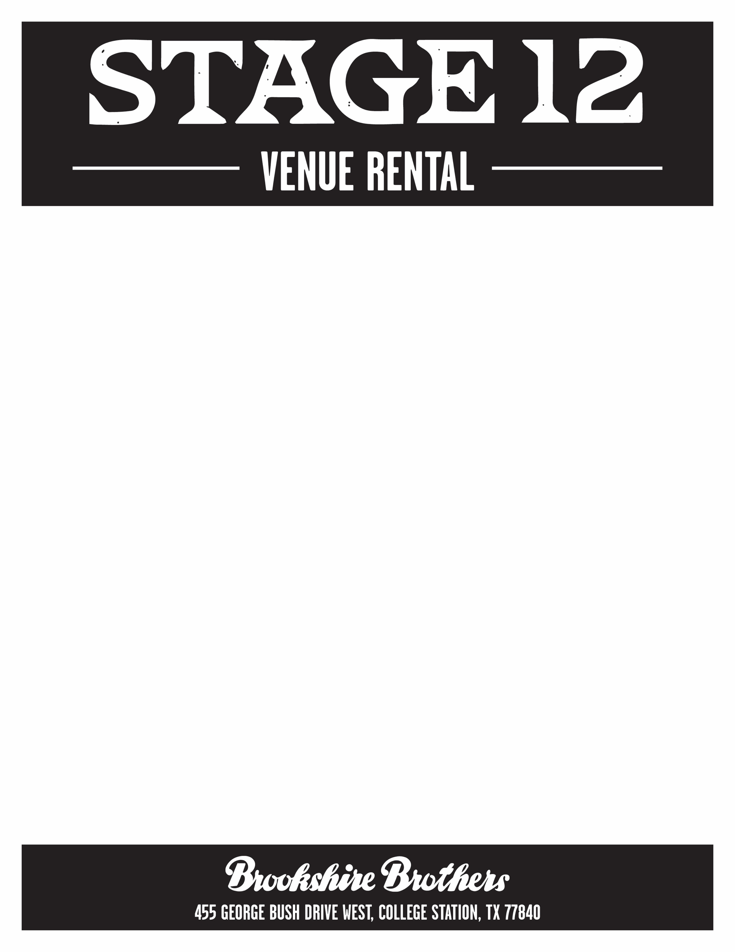
Non-Peak Times: Sunday - Wednesday 8:00 a.m. – 4:00 p.m.
Peak Times: 5:00 p.m. – midnight daily; Thursday - Saturday 8:00 a.m. – 4:00 p.m.
Non-Peak Rates
Space | Capacity | Public | TAMU-Affiliated
Stage 12 - Balcony*+ | 150 | $450 | $350
Stage 12 - Ground Level*+ | 350 | $750 | $575
Garrigan Stables Lounge | 100 | $600 | $450
All 3 spaces rented | 600 | $1,600 | $1,200

Peak Rates
Space | Capacity | Public | TAMU-Affiliated
Stage 12 - Balcony*+ | 150 | $900 | $675
Stage 12 - Ground Level*+ | 350 | $1,500 | $1,125
Garrigan Stables Lounge | 100 | $750 | $550
All 3 spaces rented | 600 | $2,800 | $2,100
* denotes view of stage/video board
+ denotes microphone available

Venue Features:
- Integrated PA system with microphone (available for additional fee)
- 15’ video board for programming (available for additional fee)
- In-house catering by Stage 12 Catering
- 3 bar locations for wine by glass and 20+ draft beer varieties
- Usage of tables/chairs
- dressing room

**Additional fees for set up, clean up, security, and parking may apply**

Learn more about the Aggie-inspired Brookshire Brothers!

